Name: R . Sharmila
Course code: CSA0606
Course name: Design and Analysis and Algorithms
Reg no:192521213
Branch: Bect(IT)
Slot: B

Title
Application: Cloud Data Backup System Using Master Theorem

Q32. Application: Cloud Data Backup System A cloud backup system divides data into smaller chunks recursively: T(n) = 2T(n/2) + n log n. Apply the Master Theorem and determine the time complexity. Identify the correct case and justify your answer. Discuss how the algorithm scales with increasing data size and interpret using asymptotic notation.

Aim
To implement a Cloud Data Backup System using recursion in the C programming language and analyze its time complexity using the Master Theorem. The objective is to understand how divide-and-conquer algorithms work in cloud computing applications and evaluate their efficiency using asymptotic analysis.

Introduction
Cloud computing has become an essential technology for storing and managing digital information. Organizations and individuals use cloud storage services to protect their valuable data from accidental loss, hardware failures, and cyber threats. A cloud backup system creates copies of files and stores them securely on remote servers, allowing users to recover their data whenever needed.
When the size of data becomes very large, processing the entire file at once is inefficient. Therefore, cloud backup systems divide large files into smaller chunks and process each chunk separately. This method improves performance and reduces processing time. The divide-and-conquer technique is commonly used in such systems because it recursively breaks a problem into smaller subproblems until they become easy to solve.
The performance of recursive algorithms is represented using recurrence relations. In this problem, the recurrence relation is:
$$T(n)=2T(n/2)+nlog⁡n$$
The Master Theorem is used to solve this recurrence relation and determine the algorithm's time complexity. This helps us understand how the algorithm behaves when the size of the input data increases.

Problem Statement
A cloud backup system recursively divides data into two equal parts. The recurrence relation is:
$$T(n)=2T(n/2)+nlog⁡n$$
Apply the Master Theorem to determine the time complexity. Identify the correct case and justify your answer. Discuss how the algorithm scales with increasing data size and interpret the result using asymptotic notation.

Objectives
- To understand the divide-and-conquer approach.
- To implement recursive data division using C programming.
- To analyze the recurrence relation using the Master Theorem.
- To determine the time complexity of the algorithm.
- To study the scalability of cloud backup systems.

Implementation
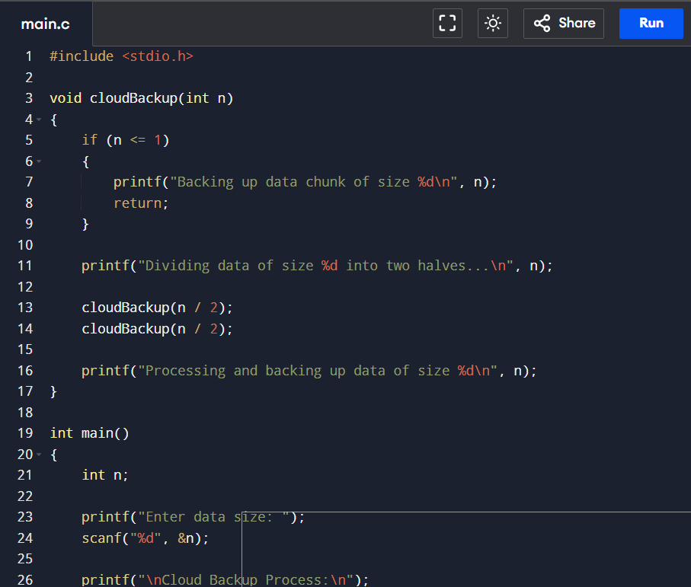

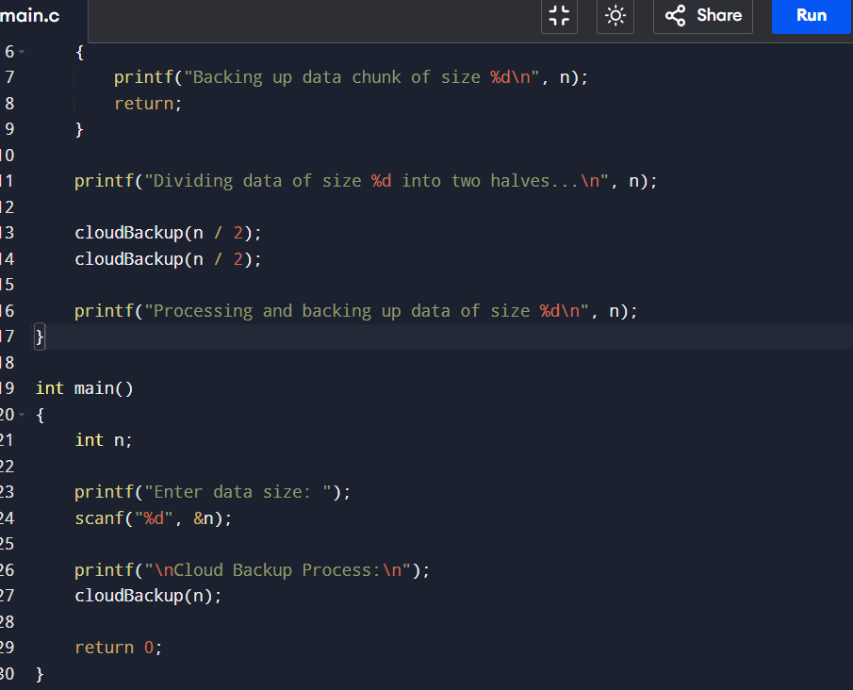

Output
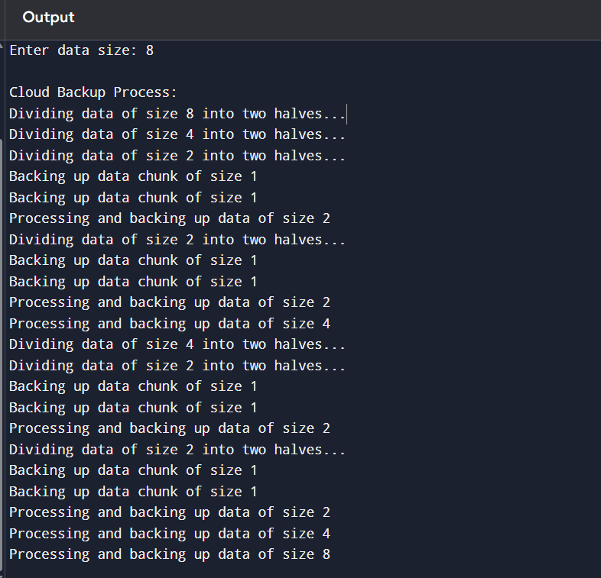

Complexity Analysis Using Master Theorem
The recurrence relation is:
$$T(n)=2T(n/2)+nlog⁡n$$
Comparing it with the standard Master Theorem:
$$T(n)=aT(n/b)+f(n)$$
We obtain:
- a = 2
- b = 2
- f(n)=n\log n
Now,
$$n^{{log⁡}_{b}a}=n^{{log⁡}_{2}2}=n$$
Since
$$f(n)=Θ(nlog⁡n)=Θ(n^{{log⁡}_{b}a}{log⁡}^{1}n)$$
the recurrence satisfies Master Theorem Case 2.
Therefore,
$$T(n)=Θ(n{log⁡}^{2}n)$$
Thus, the overall running time of the algorithm is Θ(n log² n).

Scalability
The algorithm uses recursion to divide the data into two equal parts repeatedly until the smallest chunk is obtained. At every level of recursion, additional processing of approximately n log n is performed. Because the problem size is reduced by half in each recursive step, the algorithm remains efficient even for large data sizes.
As the amount of data increases, the execution time grows at the rate of Θ(n log² n) rather than O(n²). This makes the algorithm suitable for cloud storage systems where large volumes of files must be processed quickly. The divide-and-conquer strategy also allows backup operations to be performed in parallel, improving overall system performance.

Asymptotic Analysis
- Big-O Notation: O(n log² n)
- Big-Theta Notation: Θ(n log² n)
- Big-Omega Notation: Ω(n log² n)
These notations indicate the upper bound, exact bound, and lower bound of the algorithm. Since all three are the same, the algorithm has a tight bound of Θ(n log² n).

Advantages
- Efficient for processing large datasets.
- Uses the divide-and-conquer technique.
- Reduces processing complexity.
- Supports scalable cloud backup operations.
- Easy to analyze using the Master Theorem.
- Can be extended for parallel processing.

Applications
- Cloud backup services.
- Google Drive and OneDrive-style storage systems.
- Enterprise data centers.
- Distributed storage systems.
- Disaster recovery solutions.

Conclusion
The Cloud Data Backup System was successfully implemented using recursion in the C programming language. The program demonstrated how a large data file can be divided into smaller chunks and processed recursively. Using the Master Theorem, the recurrence relation T(n)=2T(n/2)+n log n was analyzed and identified as Case 2, resulting in a time complexity of Θ(n log² n). The analysis shows that the algorithm scales efficiently with increasing data size, making it suitable for modern cloud storage and backup applications. It provides a practical example of how divide-and-conquer algorithms are applied in real-world computing systems.

References
- Thomas H. Cormen, Charles E. Leiserson, Ronald L. Rivest, and Clifford Stein, Introduction to Algorithms, 4th Edition, MIT Press.
- Ellis Horowitz, Sartaj Sahni, and Susan Anderson-Freed, Fundamentals of Data Structures in C.
- Alfred V. Aho, John E. Hopcroft, and Jeffrey D. Ullman, The Design and Analysis of Computer Algorithms.
- Course notes and lecture materials on Design and Analysis of Algorithms.

